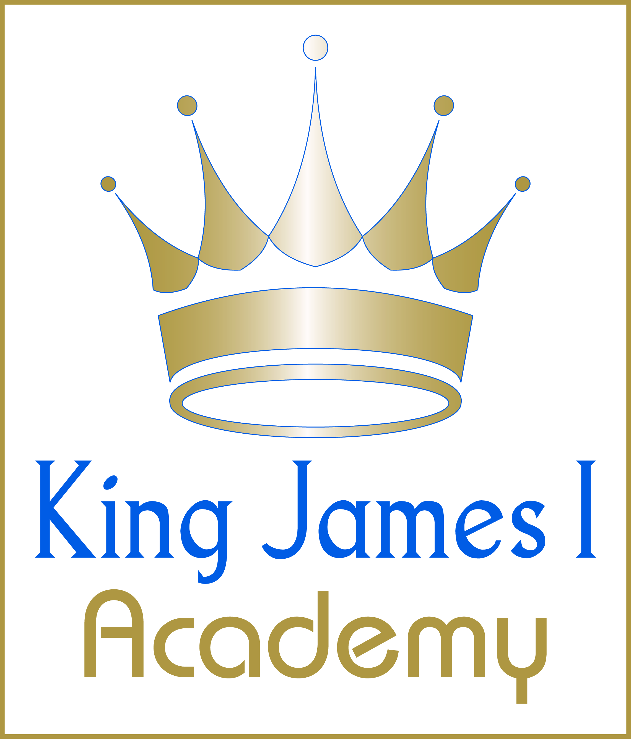
King James I Academy Sports Day Final Results 2025

Year 7
Points | Position | Tutor
121 | 1st | JHO
99 | 2nd | JTU
75 | 3rd | LBE
75 | 3rd | LLI
73 | 4th | JFR
71 | 5th | PDG
70 | 6th | CTH
64 | 7th | AVI

Year 8
Points | Position | Tutor
117 | 1st | CAR
103 | 2nd | HRA
101 | 3rd | DLE
97 | 4th | BMA
91 | 5th | SGO
78 | 6th | ABR
63 | 7th | DWH
41 | 8th | SOA

Year 9
Points | Position | Tutor
134 | 1st | VWA
110 | 2nd | JL
84 | 3rd | DHO
84 | 3rd | JSO
76 | 4th | MLA
67 | 5th | PAC
61 | 6th | JPO

Year 10
Points | Position | Tutor
100 | 1st | KBL
94 | 2nd | APA
85 | 3rd | ESM
83 | 4th | LMG
47 | 5th | IHL
46 | 6th | SRU
36 | 7th | CBU

