**KING JAMES I ACADEMY**

**PE BULLETIN**

**Ms J Humble July 2025**

**Athletics**

Students from King James represented the Academy at two different athletics events held at Sunnydale Leisure Centre. Year 9/10 participated on the 17th June and Year 7/8 on the 24th June. The best team results included the year 9 girls coming 5th out of 10 schools and the year 7 boys coming 3rd. There were also some fantastic individual performances including Tiffany Frost winning the 100m, Kaitlyn Rutherford setting a school record in the 800m and Jenson Wright setting a school record in the 200m

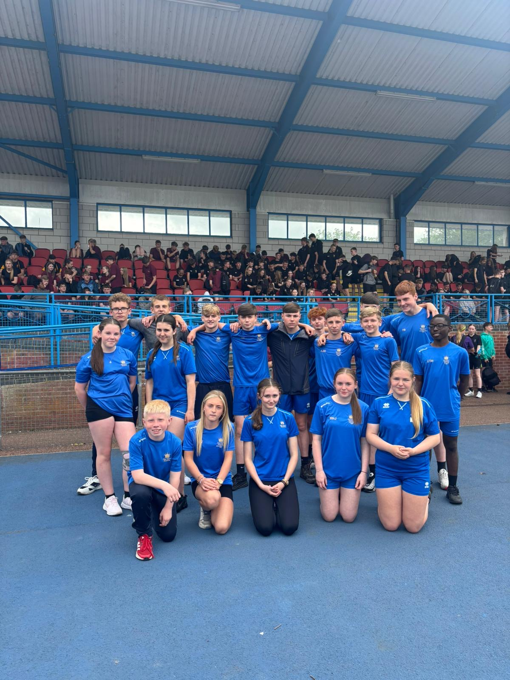

**Sports Day**

Year groups sports days took place this term on the 14th, 15th and 16th July. Every form class were given the opportunity to have a representative to compete in a range of athletics events. Events included track 100m, 200m, 400m, 800m, throws; javelin, discus and shot putt and jumps; standing triple and broad jump.

Students and staff were enthusiastic about the day and participated to an excellent standard with several school records being broken on the day. Well done to all competitors but a special well done to the winning form class in each year group.

|  |  |  |  |
| --- | --- | --- | --- |
| **Year** | **Points** | **Position** | **Tutor** |
| **7** | **121** | **1st** | **JHO** |
| **8** | **117** | **1st** | **CAR** |
| **9** | **134** | **1st** | **VWA** |
| **10** | **96** | **1st** | **KBL** |

A special well-done to 10 KBL who won the year 10 sports day, it was their last sports day and they used grit and determination to overcome the other competitors.

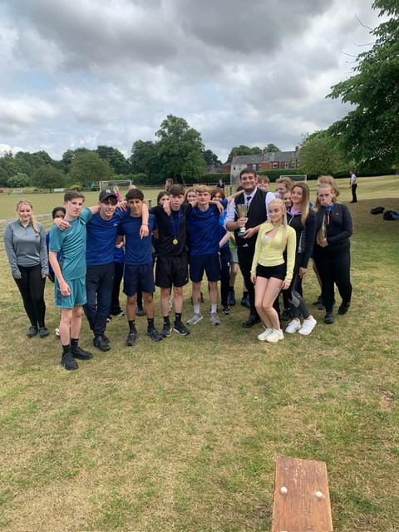



**Student of the Term**

Each PE teacher nominated a student for Summer student of the term. Congratulations to these students.

Year 7 Boys – Tyler Fieldson

Year 7 Girls – Tiffany Frost

Year 8 Boys – Wade Jefferson

Year 8 Girls – Rose Richardson

Year 9 Boys – Aiden Lapworth

Year 9 Girls – Tulisa Mulley

Year 10 Boys – Reece Robson

Year 10 Girls – Scarlett Blenkinsopp

Sixth From – Jack Lowis

**KS3 Curriculum (Sept – Oct)**

GIRLS – Baseline Assessments, Netball and Hockey

BOYS – Baseline Assessments, Football and Volleyball

**Wimbledon 2025**

Mrs Short and Mrs O'Connor took 6 year 9 girls to London for Day 2 of Wimbledon. Whilst there, the students were given access to court 2 to see tennis stars such as [L. Musetti](https://www.wimbledon.com/en_GB/players/overview/atpm0ej.html) and [B. Shelton](https://www.wimbledon.com/en_GB/players/overview/atps0s1.html). Students were able to walk around the grounds throughout the day and watch the many other athletes playing amongst the 18 courts. After their evening meal, they visited Leicester Square and M&M world.  On day 2, they were up bright and early for a few hours shopping at Covent garden before the train home.

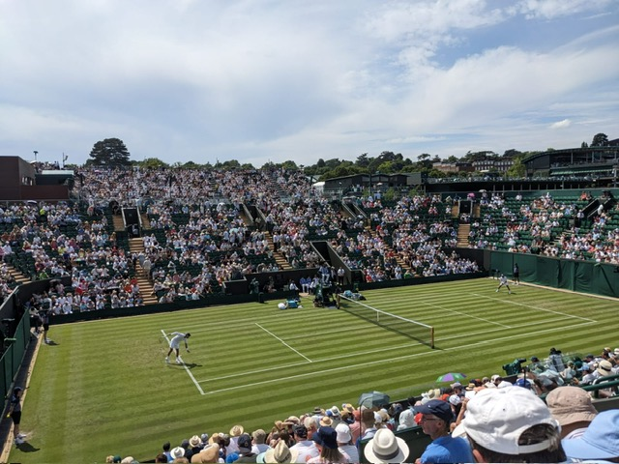





**Holland 2025**

Mr. Bushby and Mr. Raitt took 42 year 8 and 9 students to Utrecht in Holland for 5 NIGHTS. They travelled on the overnight ferry from Newcastle to Amsterdam. During their visit we had two football coaching sessions from the KNVB which are the Dutch FA at the National Training Centre. They also had two football matches against local opposition. They played Woerden and SV Houten. All games were fantastic and were played the Dutch rules where there is no throw-ins but pass-ins or dribble-ins. The best result was the B team beating SV Houten 8-0. Also, during the trip, they visited the Johan Cruyff Arena, which is the home stadium of Ajax. In their free time they went 10 pin bowling, shopping and went to the arcades. On the last day they went to Duinrell theme/water park.

