KING JAMES I ACADEMY
PE BULLETIN
Ms J Humble December 2025

Football
King James football teams have played a number of fixtures with mixed results.
Year 7 football team; Won 6-0 against Woodham. Won 7-4 against Whitworth. Drew 3-3 against Sedgefield. Lost 2-1 against St Johns.
Year 8 Football Team; Won 6-1 against Woodham. Lost 5-1 against Whitworth. Won 6-3 against Sedgefield.
Year 9 Football Team; Drew 5-5 against Whitworth. Lost 8-0 against Sedgefield. Won 4-3 against St Johns.
Year 10 Football Team; Lost 2-1 against Woodham. Lost 4-0 against Whitworth. Lost 7-1 against Sedgefield. Lost 4-1 against St Johns
Well done to all students who have represented the academy.
Fixtures recommence after February 2026 half term.

Cross – Country Championships
The district cross country championships took place at Barnard Castle. Top 16 finishers would earn their place in the county championships which will be held in January. Qualifiers for the county team are -Year 7 boys – Logan Garnett, Year 7 girls – Annie Canavan, Year 8/9 girls – Gracie Slater and Lily Metcalfe. Year 8/9 boys – Charlie Harper and Kaidon Hallimond. Well done to these students and all competitors who represented the academy.
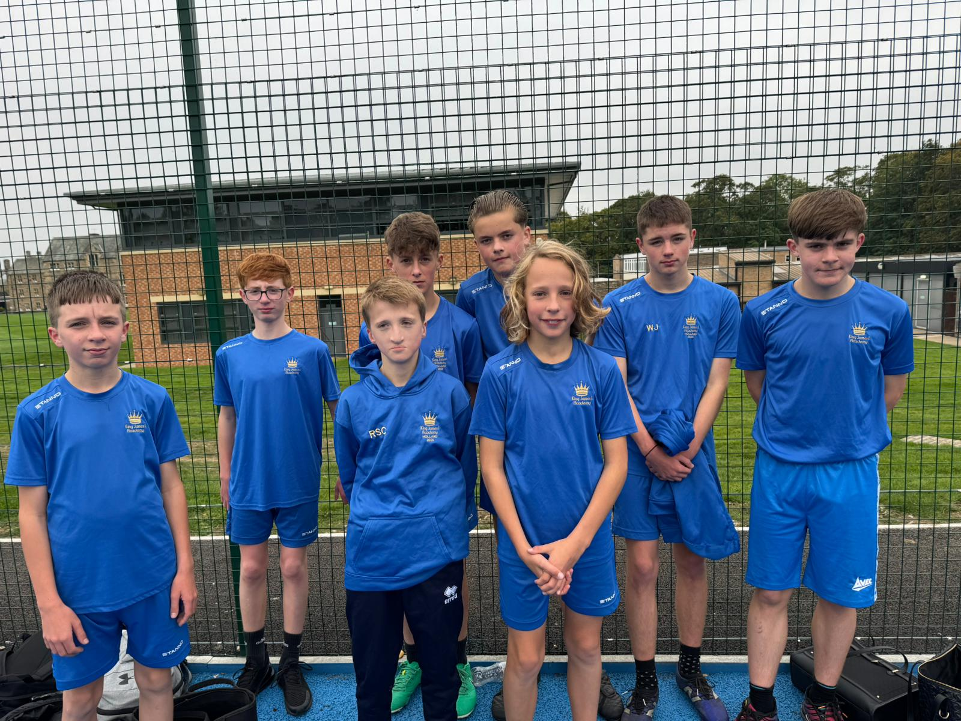

Student of the Term

Each PE teacher nominated a student for Autumn student of the term. Congratulations to these students.

Year 7 Boys – Lucas Stevens
Year 7 Girls – Holly Best
Year 8 Boys – Joshua Cherubin
Year 8 Girls – Darcy Aldridge
Year 9 Boys – Kaidon Hallimond
Year 9 Girls – Sophia Newland
Year 10 Boys – Jack Liddle
Year 10 Girls –. Kaisha Dodsworth
Year 11 Boys – Evan Hymas
Year 11 Girls – Leyla Vickers
6th Form – Nicole Anderson

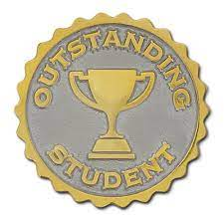
Year 7/8 Sports Hall Athletics

Year 7 and 8 Indoor Athletics Secondary School Games took place on 14/11/25 at Barrington School. Students competed in various events including relays, standing triple jump and shot putt. All teams competed well. The year 8 boys team finished first and will now go to the next round which is the county finals on the 18th February 2026.
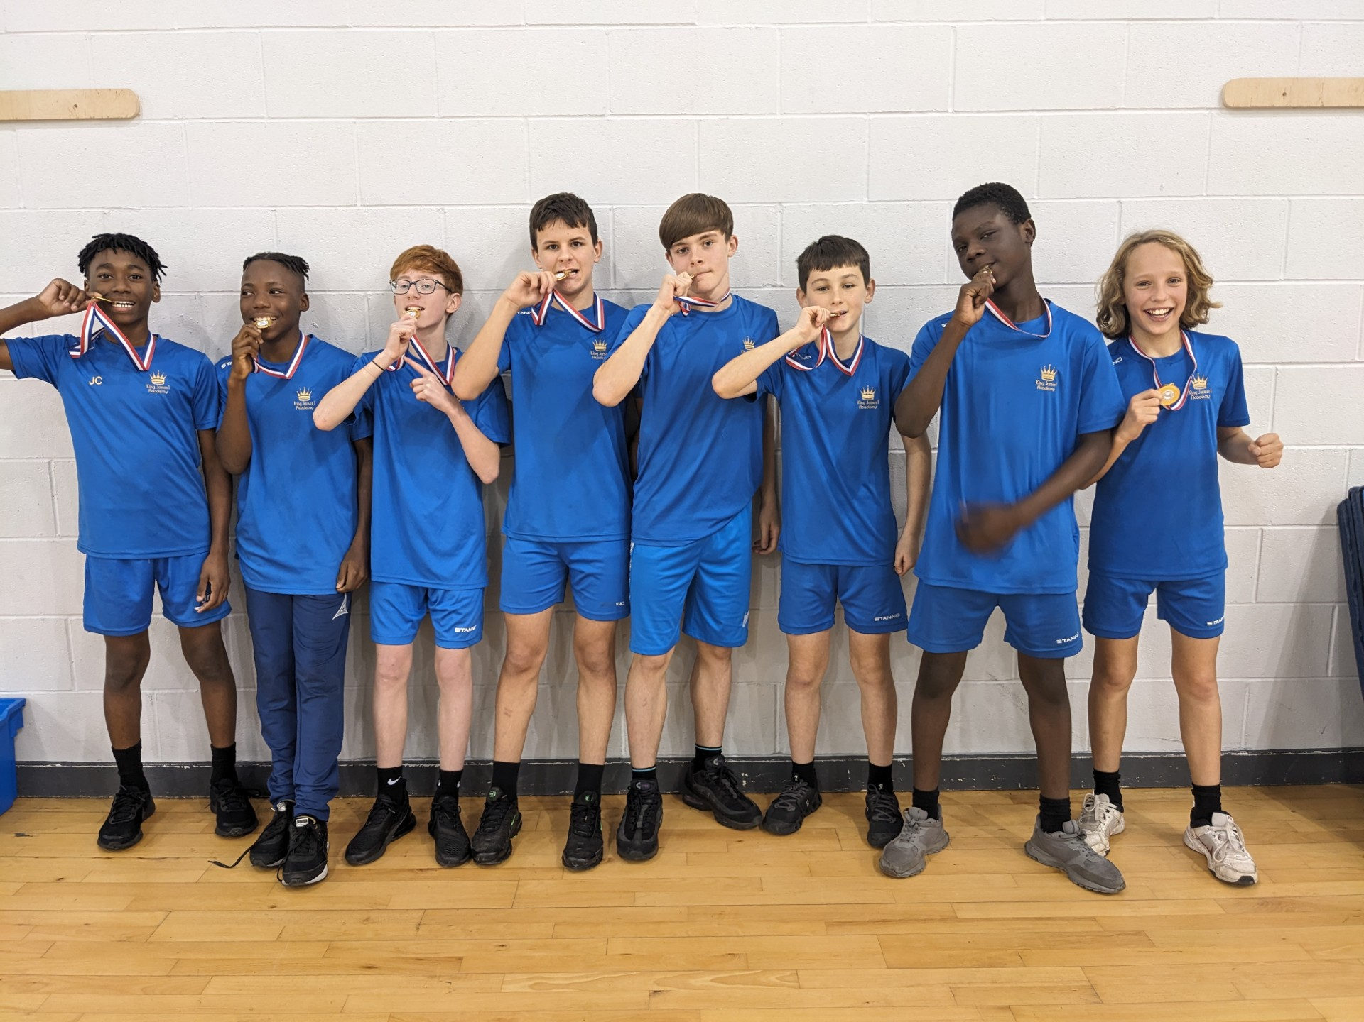

KS3 Curriculum (Jan-Mar)

GIRLS – Trampolining, Badminton, Dance and Tag Rugby.
BOYS – Trampolining, Badminton and Fitness.

