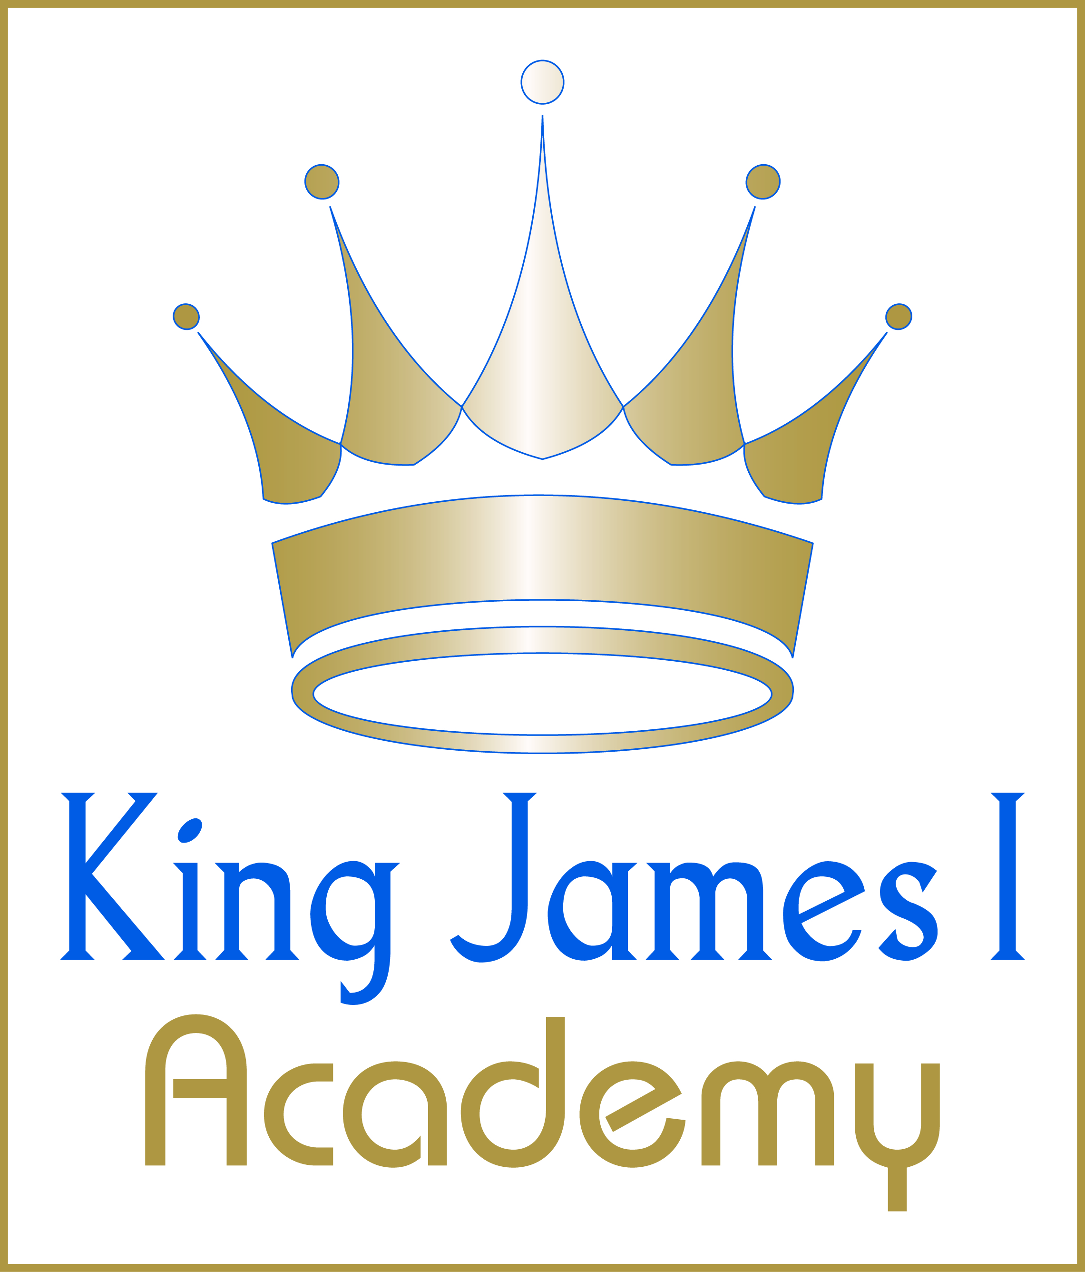

KS3 Girls PE Curriculum 2025-2026

Half Term 1
Year | Sport 1 | Sport 2
7 | Baseline Assessment | Netball
8 | Netball | Hockey
9 | Netball | N/A

Half Term 2
Year | Sport 1 | Sport 2 | Sport 3
7 | Trampolining | Badminton | Fitness
8 | Trampolining | Badminton | Fitness
9 | Trampolining | Badminton | N/A

Half Term 3
Year | Sport 1 | Sport 2 | Sport 3
7 | Trampolining | Badminton | Dance
8 | Trampolining | Badminton | Tag Rugby
9 | Rugby | N/A | N/A

Half Term 4
Year | Sport 1 | Sport 2
7 | Basketball | Cricket
8 | Basketball | Cricket
9 | Cricket | N/A

Half Term 5
Year | Sport 1 | Sport 2
7 | Football | Athletics
8 | Football | Athletics
9 | Athletics | N/A

Half Term 6
Year | Sport 1 | Sport 2
7 | Rounders | Athletics
8 | Rounders | Athletics
9 | Rounders | N/A

