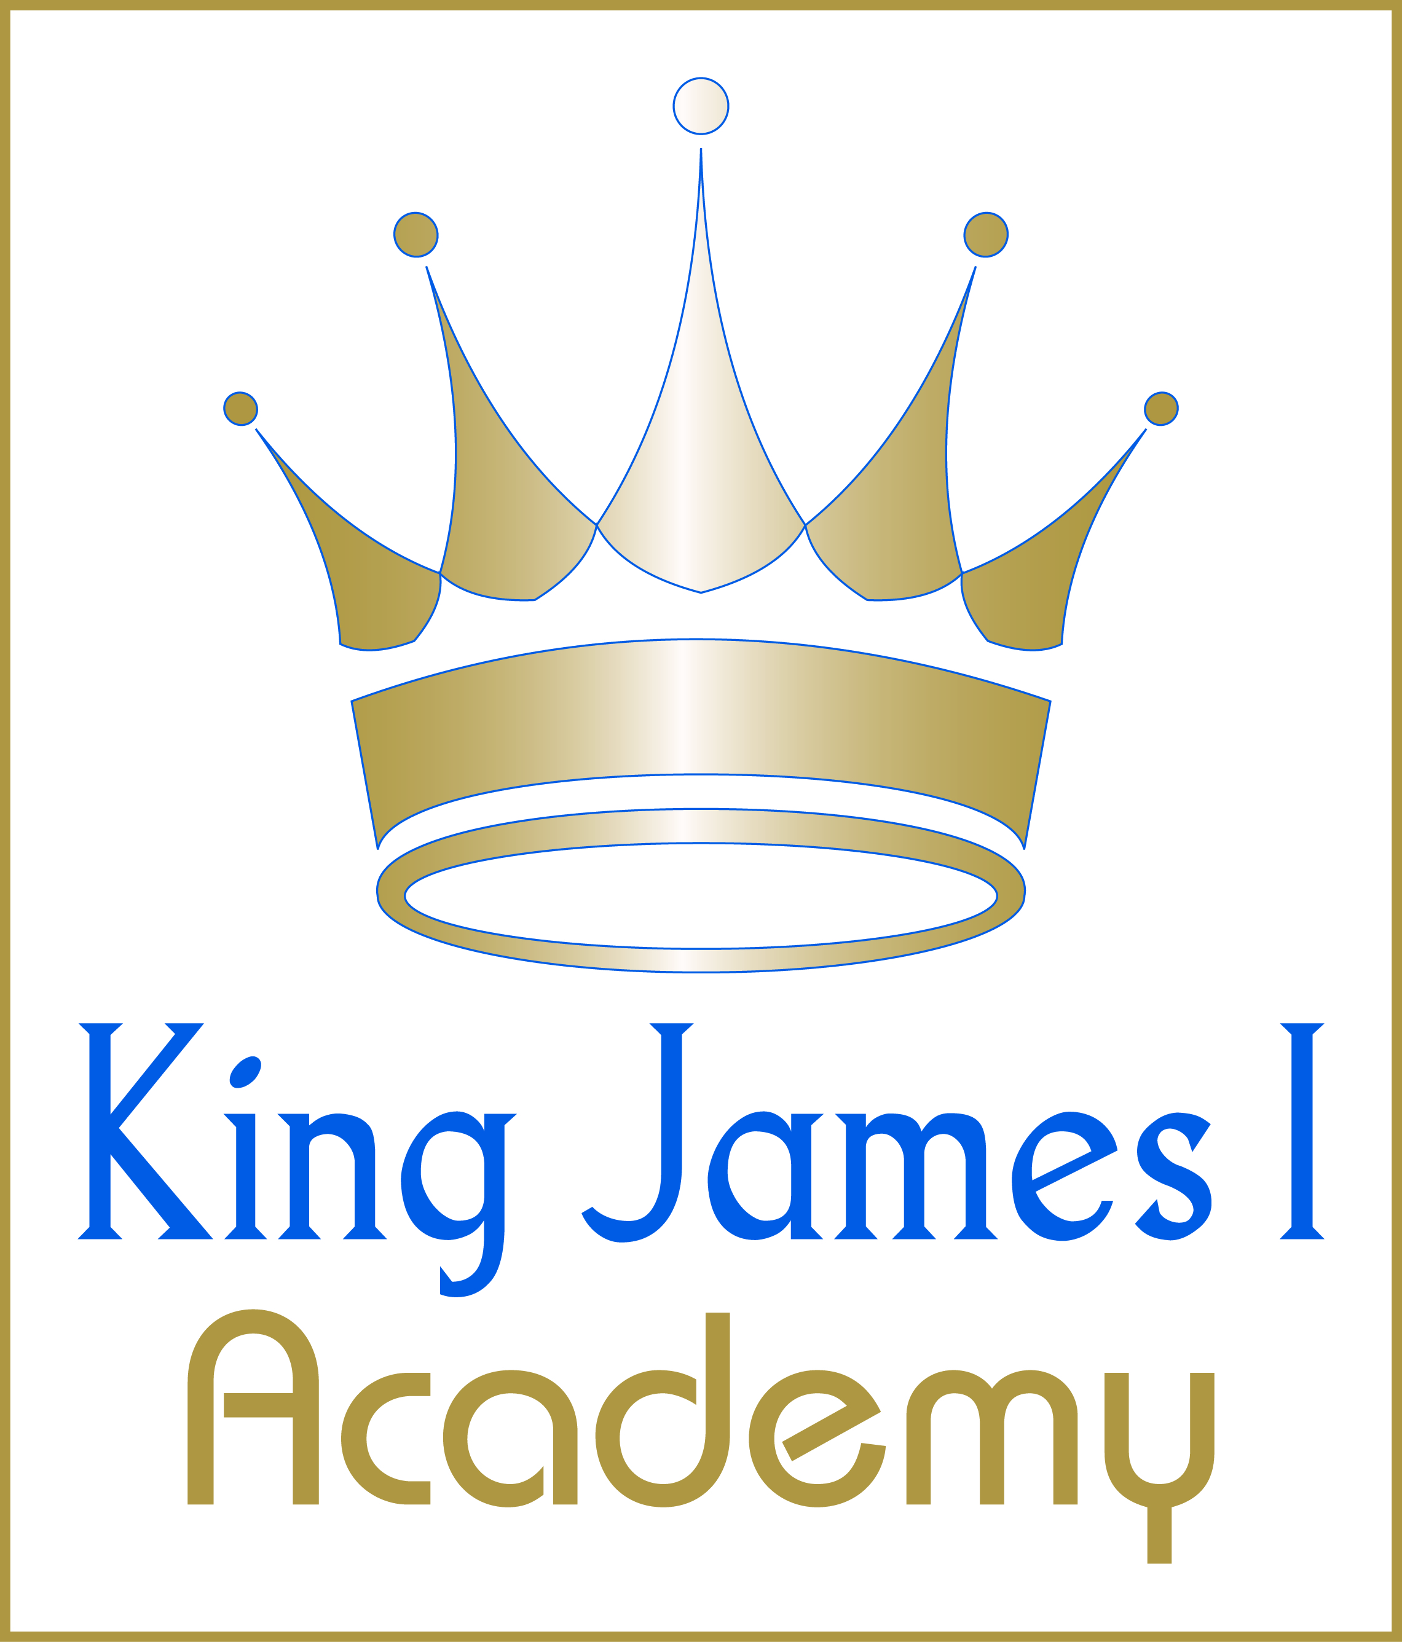

KS3 Boys PE Curriculum 2025-2026

Half Term 1
Year | Sport 1 | Sport 2
7 | Baseline Assessment | Football
8 | Volleyball | Football
9 | Football | N/A

Half Term 2
Year | Sport 1 | Sport 2 | Sport 3
7 | Trampolining | Badminton | Rugby
8 | Trampolining | Badminton | Rugby
9 | Rugby | N/A | N/A

Half Term 3
Year | Sport 1 | Sport 2 | Sport 3
7 | Trampolining | Badminton | Fitness
8 | Trampolining | Badminton | Fitness
9 | Trampolining | Badminton | N/A

Half Term 4
Year | Sport 1 | Sport 2
7 | Basketball | Hockey
8 | Basketball | Hockey
9 | Basketball | N/A

Half Term 5
Year | Sport 1 | Sport 2
7 | Softball | Athletics
8 | Softball | Athletics
9 | Softball | N/A

Half Term 6
Year | Sport 1 | Sport 2
7 | Cricket | Athletics
8 | Cricket | Athletics
9 | Athletics | N/A

