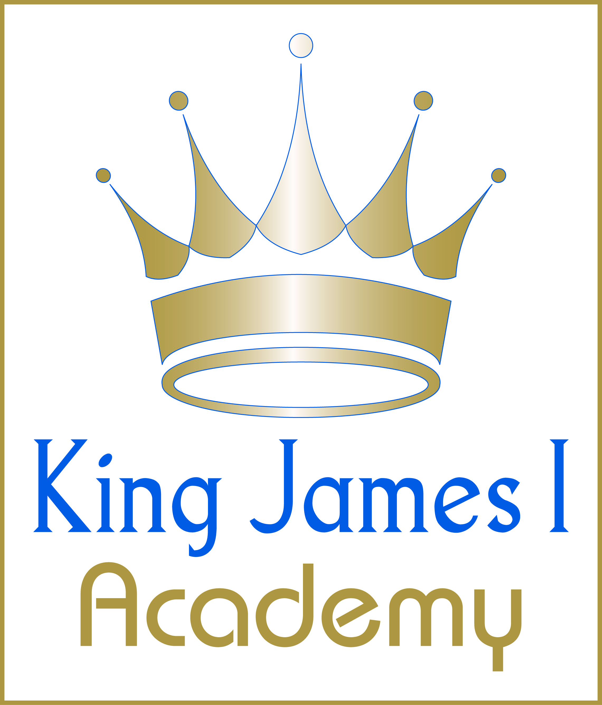
King James I Academy
Physical Education Department
AFTER SCHOOL P.E. AND SPORT CLUBS
(2021-2022)

 | KS3 | KS4
MONDAY | FOOTBALL  (ABS & DR)  NETBALL  (KCO & JSH) | FOOTBALL  (ABS & DR)  NETBALL  (KCO & JSH)
TUESDAY | FOOTBALL & NETBALL FIXTURES | FOOTBALL & NETBALL FIXTURES
WEDNESDAY | BADMINTON/SHORT TENNIS  (JHM) | BADMINTON/SHORT TENNIS  (JHM)
THURSDAY | FOOTBALL & NETBALL FIXTURES | FOOTBALL & NETBALL FIXTURES
FRIDAY | STAFF ACTIVITIES | STAFF ACTIVITIES

