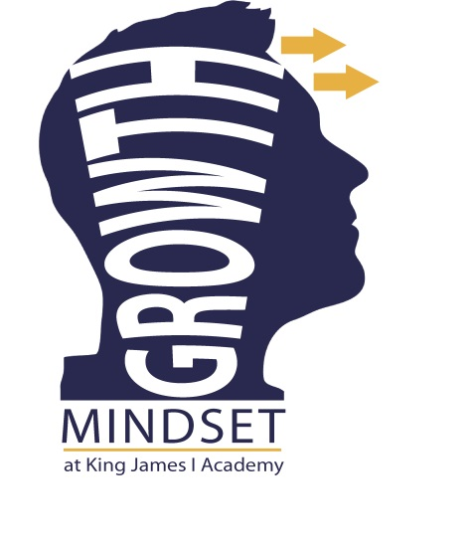

Fixed Mind Set -Some students will give up on difficult tasks easily or avoid doing tasks which they have previously found difficult. They have fixed ideas about what they are good at and are reluctant to try things which they find difficult.

Growth Mind Set - Some students are not daunted by failure. They will continue to try harder to improve their abilities. They are more likely to be resilient throughout their life and overcome obstacles through practice.

What can you do?

What can you do………

* Have high expectations of your child, it’s a self-fulfilling prophecy!
* Encourage them to be resilient and keep trying – the process they use is often more important than the outcome.
* When they make a mistake, don’t criticise! Use it as learning opportunities: “What could you have done different?” “Why did it not work out?” “What can we do next?”
* Rather than focusing on their natural talents; Focus on their effort, strong work ethic, overcoming mistakes
* Encourage your child to take risks, this is how they will learn and understand the process better even if it does not produce the result they would like.

Why “Growth Mind Set”?

Outcomes from a whole school student survey revealed that students at King James lacked confidence in their own ability and tended to give up when challenged with difficult tasks. To support our students we are developing growth mind set language and teaching, learning and assessment strategies to support our students to succeed in all aspects of home and Academy life.

What is Growth Mind set?