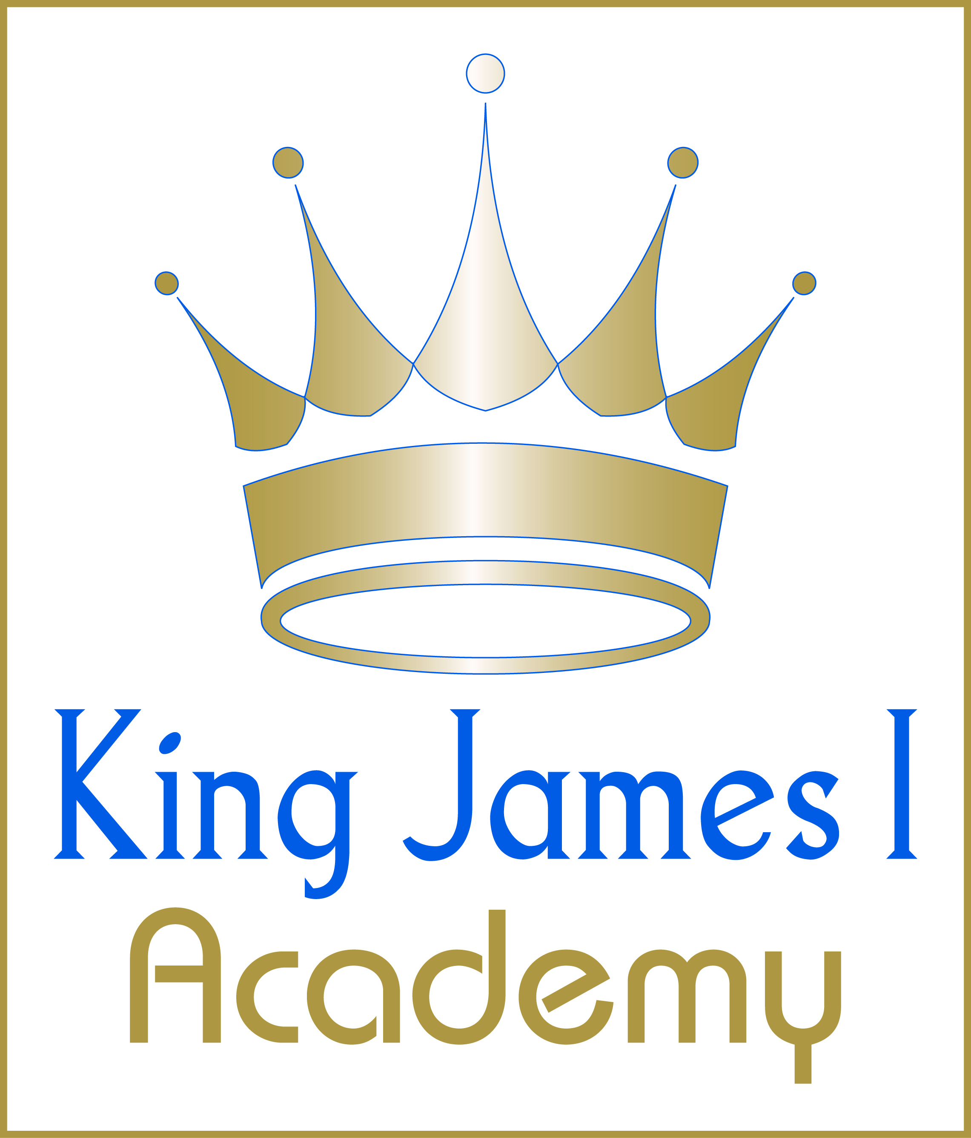
King James I Academy
Physical Education Department
AFTER SCHOOL P.E. AND SPORT CLUBS
(2022-2023)
 | KS3 | KS4
MONDAY | FOOTBALL  (ABS & DR)  NETBALL  (JSH & JHM) | FOOTBALL  (ABS & DR)  NETBALL  (JSH & JHM)
TUESDAY | GIRLS FOOTBALL (KCO)  FOOTBALL & NETBALL FIXTURES | GIRLS FOOTBALL (KCO)  FOOTBALL & NETBALL FIXTURES
WEDNESDAY | BASKETBALL  (ABS) | BASKETBALL  (ABS)
THURSDAY | FOOTBALL & NETBALL FIXTURES | FOOTBALL & NETBALL FIXTURES
FRIDAY | STAFF ACTIVITIES | STAFF ACTIVITIES

